Software Requirements Specification
For
CHAT ANALYSIS WITH NSSF CUSTOMER SUPPORT DEPARTMENT
Version 1.0 approved
Prepared by group23
Makerere University, College of computing and Informatics Sciences, Software Engineering
27th/June/2018
Table of Contents
Table of Contents ii
Revision History ii
1. Introduction 1
1.1 Purpose 1
1.2 Document Conventions 1
1.3 Intended Audience and Reading Suggestions 1
1.4 Product Scope 1
1.5 References 1
2. Overall Description 2
2.1 Product Perspective 2
2.2 Product Functions 2
2.3 User Classes and Characteristics 2
2.4 Operating Environment 2
2.5 Design and Implementation Constraints 2
2.6 User Documentation 2
2.7 Assumptions and Dependencies 3
3. External Interface Requirements 3
3.1 User Interfaces 3
3.2 Hardware Interfaces 3
3.3 Software Interfaces 3
3.4 Communications Interfaces 3
4. System Features 4
4.1 System Feature 1 4
4.2 System Feature 2 (and so on) 4
5. Other Nonfunctional Requirements 4
5.1 Performance Requirements 4
5.2 Safety Requirements 5
5.3 Security Requirements 5
5.4 Software Quality Attributes 5
5.5 Business Rules 5
6. Other Requirements 5
Appendix A: Glossary 5
Appendix B: Analysis Models 5
Appendix C: To Be Determined List 6

Revision History
Name | Date | Reason For Changes | Version

Introduction

Purpose
This document defines the requirements specifications of the chat analysis with NSSF customer support department version1.0 for analyzing and visualizing the chat history with their clients.
This document covers the specifically the analysis of the chat between the client and customer care support at NSSF.

Document Conventions
This document uses the IEEE reference format. Section headings indicated by whole numbers (1, 2, 3 …) and sub-section headings numbered basing on the whole numbers their section headings such as 1.3 belongs to section 1 are written with a bold-faced text for emphasis. Italic text is used to label diagrams. The document is written using font-family Times New Romans and line spacing of 1.5, text alignment is justify and a font size of 12.

Intended Audience and Reading Suggestions
This document is to be read by the project managers, the development team, the documentation writers, testers, the agency stake holders associated with manufacturing hardware and providing the necessary software and the agency shareholders to learn about the project and understand the requirements of the system.
- The project managers and the developers need to become intimately familiar with this Requirement document.
- The marketing staff should understand the overall description and the external interface requirements of this document to become accustomed to the various product features in order to effectively advertise the product.
- The Testers need to be well versed with the system features of the document to develop meaningful test cases and give useful feedback to the developers.
- The stake holder associated with manufacturing hardware need to review the External Interface Requirements, Nonfunctional and Functional Requirements of this document to know the requirement specifications of the needed hardware.

Product Scope
The chat analysis with NSSF customer support department system will analyze and visualize the chat history between the clients and the customer care department to determine problems faced by the clients and how the customer care department interacts with the clients towards helping to solve their problems. It will be based a computer that has RStudio, a free and open source integrated development environment for R programming language installed on it together with the Shiny packages and other relevant packages.
The objective of the system is to provide a visual and statistical representation of the Chat history to the NSSF agency which will be assist the agency in making operational plans, strategic planning and decision making to improve communication rate between the customer care department and the client.
The objectives of the system are:
- To analyze the email content and identify the most queried subject or what visitors complained of most.
- To get rid of inapplicable data.
- To also analyze employee efficiency because it is not the same for the different employees.
- To use this data and predict the time periods when visitors use the system most so that NSSF customer care is prepared
- To visualize this data and based on the feedback of visitors on certain issues, NSSF can know how better to sensitize the services it offers
- To visualize this data and know which search engines that the visitors use most to access their system
- To also visualize this data and know where most visitors come from

Overall Description

Product Perspective
This is a new product for the NSSF customer support department. It has been developed for this department to use it as a means of analyzing easily the problems faced by the clients through analyzing the Emails received from them. It is an open source project and it has a very active developer team to support it and provide feedback to users. It was developed to run on Windows, Mac OS X and Linux.

Product Functions
Systems to level diagram 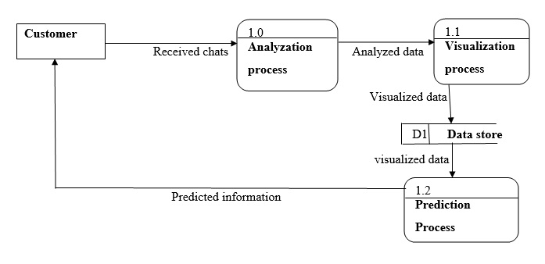
Figure 1. Showing process of receiving and replying messages between a customer and the customer support center and storing them.

User Classes and Characteristics
Data Administrator:
The DAdmin is expected to have an IT field appropriate Diploma or equivalent certification and experience of at least 2 years as a DAdmin. He /she has full access the data store for maintenance and any updates that come in.
Data Analyst:
The DAnalyst is expected to have a field appropriate college degree and experience of at least 2 years in the IT field as a Data Analyst. He / She will need a laptop connected to the web server over the internet and access the data store and the system interface in order to analyze the data. Viewing and select permissions to the data store will be granted to the DA by the DAdmin. The data analyst should be able to use the tools as provided on the site for analyzing data and visualizing it. The analyzed data includes the messages received from the clients and the responses sent to the clients.

Operating Environment
The system will operate effectively on a computer whose ram is at least 2GB with an average processing speed of at least 2.0 GHz. The computer should have Linux operating system 12.04 and above or Windows operating systems 7 and above on which R and RStudio has been installed.
The system interface will require an up to date browser such as Chrome version: 59.0.3071 and above, Firefox version 52.0 and above.

Design and Implementation Constraints
The system is constrained by a number of factors as highlighted below:-
- Hardware Constraints:
The system will be able to support less than 25 users a time with Repository of 10-60GB, having a minimum configuration of 1GB – 2GB RAM, 1-2 Cores(1.86 GHz), 30-180 GB SATA (hard disk) and configuration for better performance 2GB – 4GB RAM.
- Time constraint:
The system must be delivered by 6th August of 2018.
- Cost constraint:
The design phase requires a lot of expenses in terms of stationery, Internet among others.
- Technology Constraints:
The system will require use of web-based server technologies such as R Shiny Server, Statistical analysis, visualization tools such as the R language and it will not have a database.
- Language requirement:
The system will strictly use English as its standard language.
- Programming standards:
The system software will be maintained by the development team.

User Documentation
- System User Manual (PDF document).
- System tutorials (PDF document).
The above documents will be delivered with the system software.

Assumptions and Dependencies
The system is developed in R using RStudio and therefore requires R to be installed on the user’s computer. The user must have all the required R packages for the system to run. It requires the latest R version 3.4.0 or higher, and this applies to both windows and Linux users.

External Interface Requirements

User Interfaces
System login page interface for the customer support department

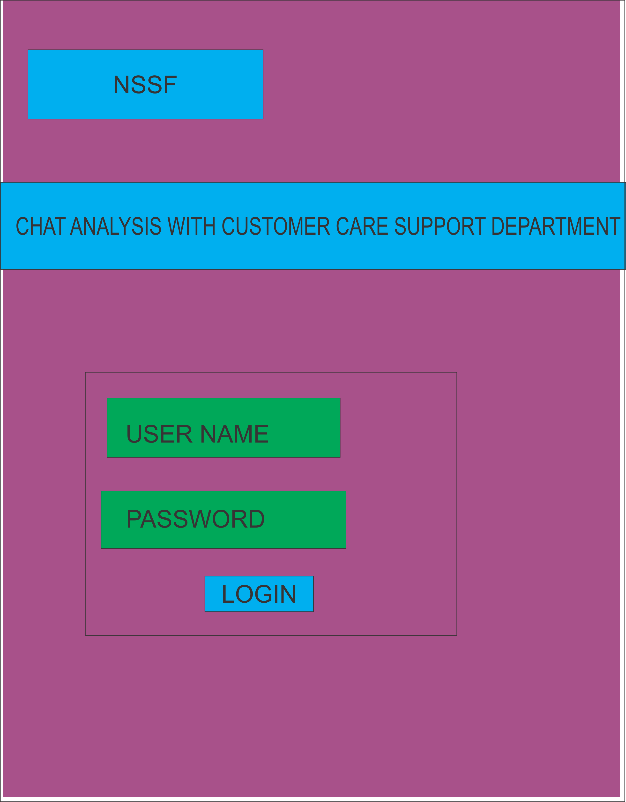

Systems success page
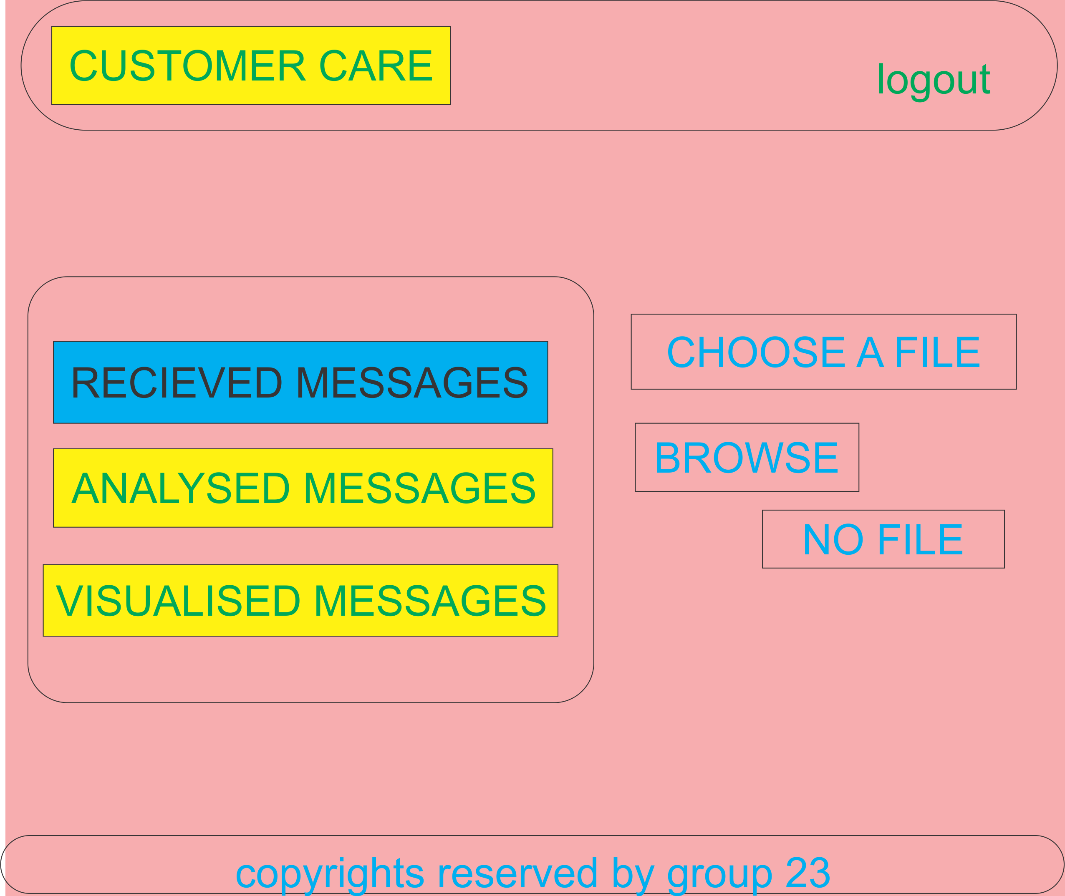

Hardware Interfaces
The minimum hardware requirements of the system are 1GB – 2GB RAM, 1-2 Cores(1.86 GHz), 30180 GB SATA (hard disk) and configuration for better performance 2GB – 4GB RAM. A compatible graphics card is required for efficient visualization. A system with these specifications can handle a Network of approximately 1000 edges and nodes. For bigger networks, additional memory is required.

Software Interfaces
The system requires R and RStudio to be installed on the system, more specifically R version 3.4.0 and above for its latest release. Additional information can be found on section 2.7 of this document.

Communications Interfaces
The system requires an internet connection to install new packages, update already installed ones and update some of its components (APIs, modules etc.), and verification of users. Additional
Information on communication protocols can be found on section 2.5.

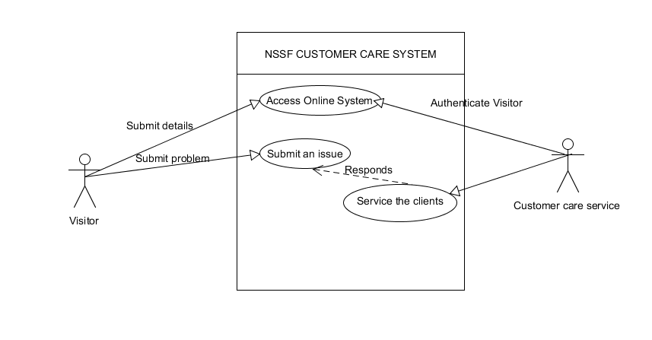
System Features

Access Online System

Description and Priority
This is a high priority feature since for any visitor who has an issue they can get a solution from the online system. In case the visitor accesses the online system they are able to check their benefits plus any other add-ons from the NSSF website.

Stimulus/Response Sequences
Visitors using their default browser access the NSSF website.
Visitors then enter their credentials.
The credentials are checked and verified.
Access to requested page is either rejected or accepted by the system depending on the security constraints put in place.

Functional Requirements
REQ-1: Browser. The browser will alert the user in case they enter the wrong details.
REQ-2: High Speed Internet Access. For the user to connect to the NSSF servers, high speed internet access is a must have. Inability to access the NSSF servers with “Page Not Found” error.
REQ-3: Computer device like a phone or a computer. In order for the above 2 to work the user must have a device in which the software can run.

Submit an issue

Description and priority
When the visitor’s credentials are verified and one is allowed to access a page of their choice, certain issues arise like forgotten passwords, some visitors don’t know what to do when they want to view their credit information. This is a high priority issue because the clients come first.

Stimulus/Response Sequence
Visitors login successfully.
An issue arises
Visitors then submit issue to the customer care

Functional Requirements
REQ-1: Browser. The browser will alert the user in case they enter the wrong details.
REQ-2: High Speed Internet Access. For the user to connect to the NSSF servers, high speed internet access is a must need. Inability to access the NSSF servers with “Page Not Found” error.
REQ-3: Computer device like a phone or a computer. In order for the above 2 to work the user must have a device in which the software can run.

Service the clients

Description and priority
When the visitors have issues and they submit them t the support desk, they need answers to their queries making this still a high priority case. The support desk is responsible for giving clear answers to the visitors.

Stimulus/Response Sequence
Visitors login and given access to page of interest.
An issue arises
Issue submitted to support desk
Support desk responds with an answer

Functional Requirements
REQ-1: Browser. The browser will alert the user in case they enter the wrong details.
REQ-2: High Speed Internet Access. For the user to connect to the NSSF servers, high speed internet access is a must need. Inability to access the NSSF servers with “Page Not Found” error.
REQ-3: Computer device like a phone or a computer. In order for the above 2 to work the user must have a device in which the software can run. For both the visitors and support desk.

Other Nonfunctional Requirements

Performance Requirements
The minimum hardware requirements of the system are 1GB – 2GB RAM, 1-2 Cores(1.86 GHz), 30180 GB SATA (hard disk) and configuration for better performance 2GB – 4GB RAM. A compatible graphics card is required for efficient visualization. A system with these specifications can handle a Network of approximately 1000 edges and nodes. Performance depends on the RAM size of the system.

Safety Requirements
To ensure that none of the system’s users loses any data while using the system (due to a crash or a bug of some kind), the data administrator updates the system regularly.

Security Requirements
The system security requirements are the information about a user that was stored in the system during signing up with the NSSF to open up an account or the google account credentials. The data used is expected to be encrypted.

Software Quality Attributes
The system provides the users with both simple and advanced features. Due to its well designed and easy to use interface it can be used by both experts and typical users. However, users must already have a basic knowledge of graphs before using it to enable easy understanding of them.

Business Rules
Every employee at the Customer Support Department is meant to login before accessing the site. The Data Administrator has a privilege of viewing all the data that has entered the system and all track all sorts of data processes such as Analyzing, Visualizing and predicting the data. The Workers are privileged to seeing the predicted information before sending a response to the client.

Other Requirements
Appendix A: Glossary
- NSSF: National Social Security Fund.
- OS: Operating System.
- PDF: Portable Document Format.
- RAM: Random Access Memory.
- DAnalyst: Data Analyst.
- DAdmin: Data Administrator.
- REQ: Requirements

References
Books [1] Gary B Sherry, Harry J Rosenblatt, System analysis and design ninth edition, Library of Congress Control Number: 2010943248,ISBN-13: 978-0-538-48161-8,ISBN-10: 0-538-481617,Course Technology, 20 Channel Center Street, Boston, MA 02210, US

Links:
https://www.nssfug.com

